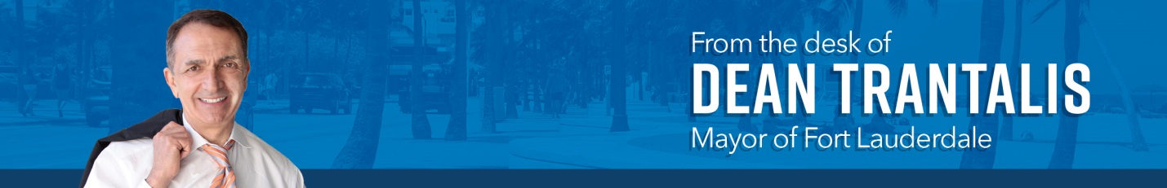

April marked the one-year anniversary of one of most extreme weather-related disasters to hit the city of Fort Lauderdale. On April 12, our community was inundated with more than 26 inches of rain in a mere matter of hours and the result left many neighborhoods and homes under water.

As we reflect on what occurred, what stands out to me is Fort Lauderdale’s indomitable spirit to come together as a community. No city could be prepared for a storm that occurs once in a thousand years, but we worked together to recover and are acting quickly to increase our resiliency to address the world’s changing climate.

In those first couple days a year ago, our police and fire personnel responded to thousands of calls and our public works crews worked around the clock. The city manager and I worked closely with federal emergency management officials to obtain disaster assistance in record time.

In the end, the federal government paid out almost $100 million in aid – helping repair homes, reimbursing temporary lodging and replacing essential property.

Since the storm, the city has accelerated its work on upgrading the stormwater system.
The fact is that segments of Fort Lauderdale long lacked needed infrastructure to protect residents and property from flooding, but we are changing that.

Work in the Edgewood neighborhood, one of the hardest hit areas, has been completed. With an investment of $14.5 million, we have reduced the frequency, intensity and duration of flooding.

A similar project in River Oaks is underway and close to completion. It includes the installation of three stormwater pump stations. And, construction is ongoing in the Durrs neighborhood. In that area, the city is undertaking $30 million in stormwater improvements, including laying 6.6 miles of pipe.

Design work for improvements in Melrose Manors has started. We expect construction there to start in 2026 with an investment of up to $90 million.

Last fall in my State of the City speech, we unveiled plans to go even further. We launched Fortify Lauderdale.

This ambitious plan calls for the city to invest up to a half-billion dollars over the next decade. This work will encompass 17 neighborhoods and more than double the amount of upgrades that had been planned.

To accomplish this, engineers from our Public Works Department have been engaged in a vulnerability assessment to identify and prioritize our greatest risks. The construction will be supplemented by a companion program that will assist residents with information on how they can better protect their homes and property.

This fast-paced, new initiative belies the fact that the city had actually been making great strides over the past several years in improving our utility infrastructure, including the stormwater system.

Since I became mayor in 2018, the city has constructed more than 19 miles of water pipe, 17 miles of sewer pipe and 15 miles of stormwater pipe. We are determined to make Fort Lauderdale the most resilient city that it possibly can be.

Also, this month, we’ve had some exciting economic development news: our movie studio project moved a step closer to fruition. The developers of the project announced their primary tenant – Infinite Reality – and that the company would be creating more than 1,000 high-paying jobs.

The studio initiative is a bold testament to our belief in Fort Lauderdale's potential and our dedication to building a future where innovation, artistic opportunity and economic growth thrive hand-in-hand. This state-of-the-art content creation complex with its sound stages and film sets will attract major film, television and streaming productions.

The studio owners say they have financing in place and expect to proceed through the city’s development approval process in the coming months.

It’s great to be able to create so many jobs and help expand the film industry in South Florida. But this project is more than that.

It also transforms the old Wingate landfill and incinerator site, breathing new life into an underutilized area of the city. Wingate is a former Superfund site that the city cleaned up the parcel two decades ago only to see no interest until now in its redevelopment.

This studio will be a beacon of innovation, education and opportunity. It includes a very special education component with an on-site film school.

An agreement with Florida Atlantic University is in place, and agreements with more schools, like Nova Southeastern University and others, are in the works. The team also is working with Broward County Schools to create an internship program with Dillard High School.

By training a new generation in the trades and skills essential to high-tech content creation and movie production, we are providing pathways to success for our own residents.

I hope the movie studio complex will be a magnet for investment, drawing talent, businesses and film productions from far and wide. That would create a ripple effect throughout our economy, generating jobs in diverse sectors ranging from construction to hospitality. It’s a truly exciting prospect.

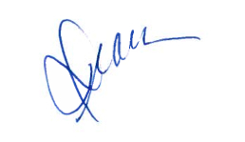
Yours,

Dean

